**JOBSHEET 7**

**Searching**



**Name**

Sherly Lutfi Azkiah Sulistyawati

**NIM**

2341720241

**Class**

1I

**Major**

Information Technology

**Study Program**

D4 Informatics Engineering

**Practicum 1: Sequential Search Method**

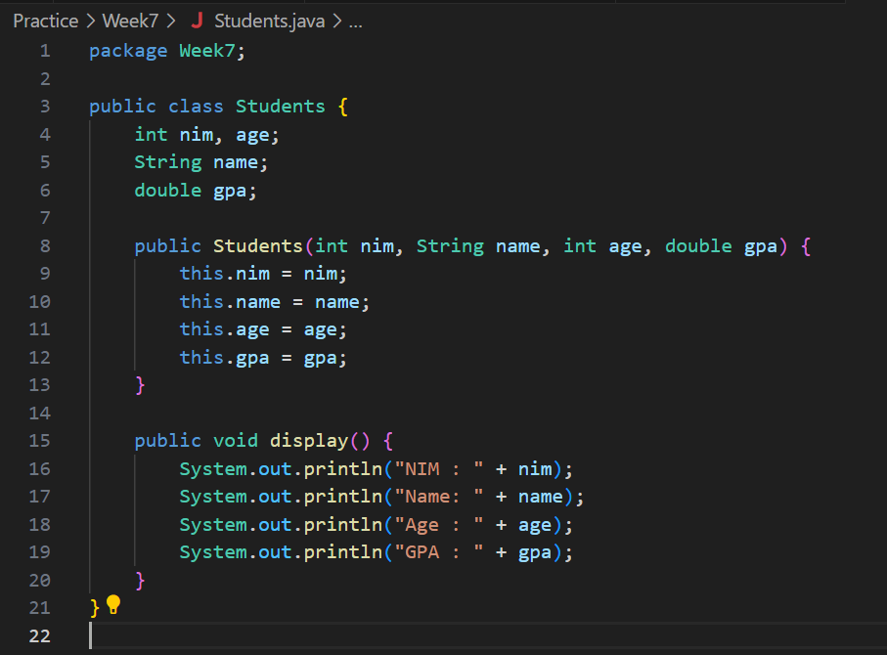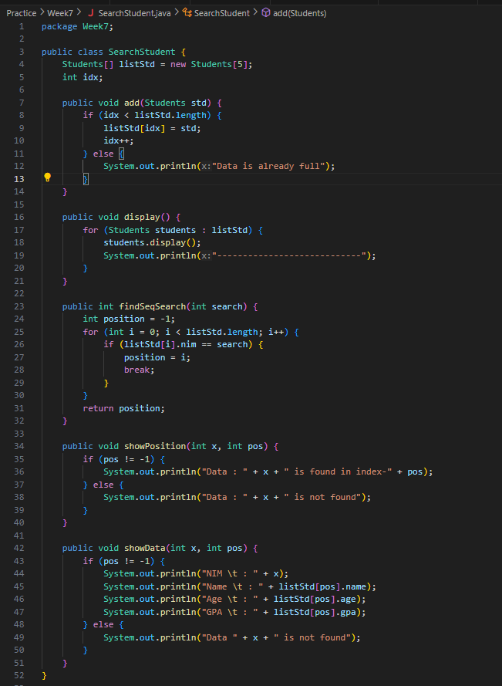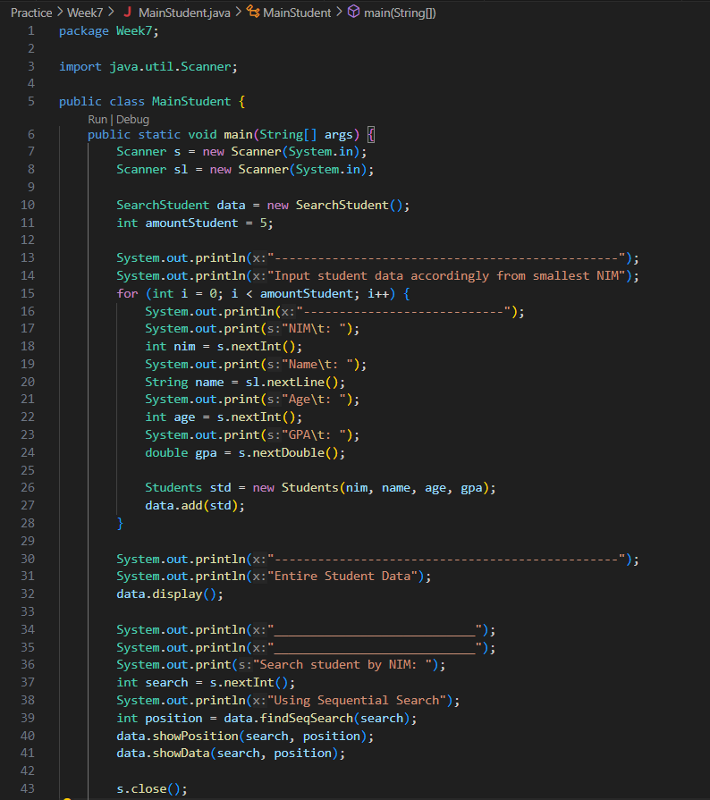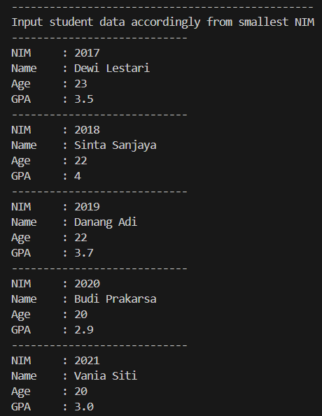 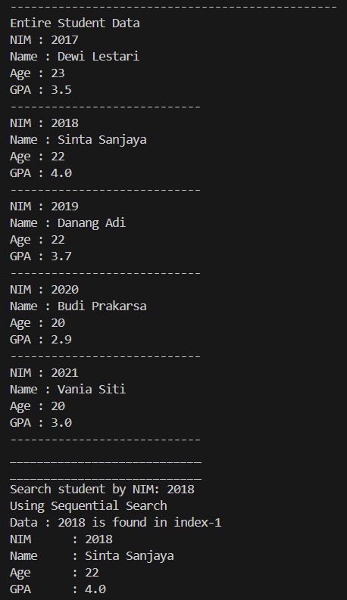

**Question**

1. What is the difference of method **displayData** and **displayPosition** in **StudentSearch** class?
2. What is the function of break in this following program code?

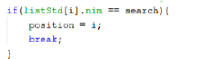

1. If inserted NIM data is not sorted from smallest to biggest value, will the program encounter an error? Is the result still correct? Why is that?

**Practicum 2: Binary Search Method**

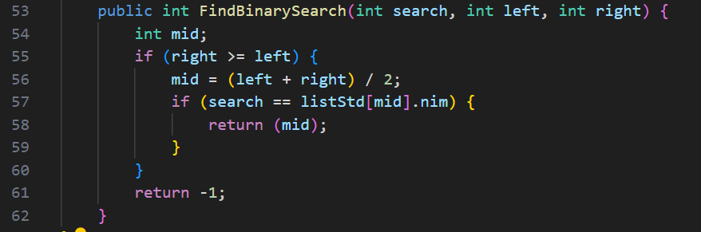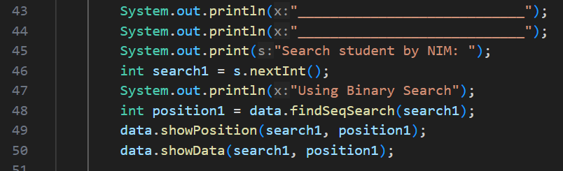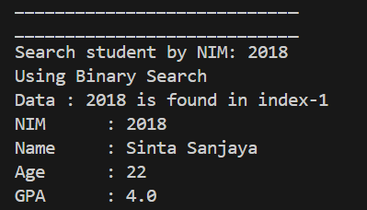

**Question**

1. Show the program code in which runs the divide process
2. Show the program code in which runs the conquer process
3. If inserted NIM data is not sorted, will the program crash? Why?

If inserted NIM data is sorted from largest to smallest value (e.g 20215, 20214 20212, 20211,20210) and element being searched is 20210. How is the result of binary search? Does it return the correct one? if not, then change the code so that the binary search executed properly

1. Modify program above so that the students amount inserted is matched with user input

**Practicum 3: Review Divide and Conquer**

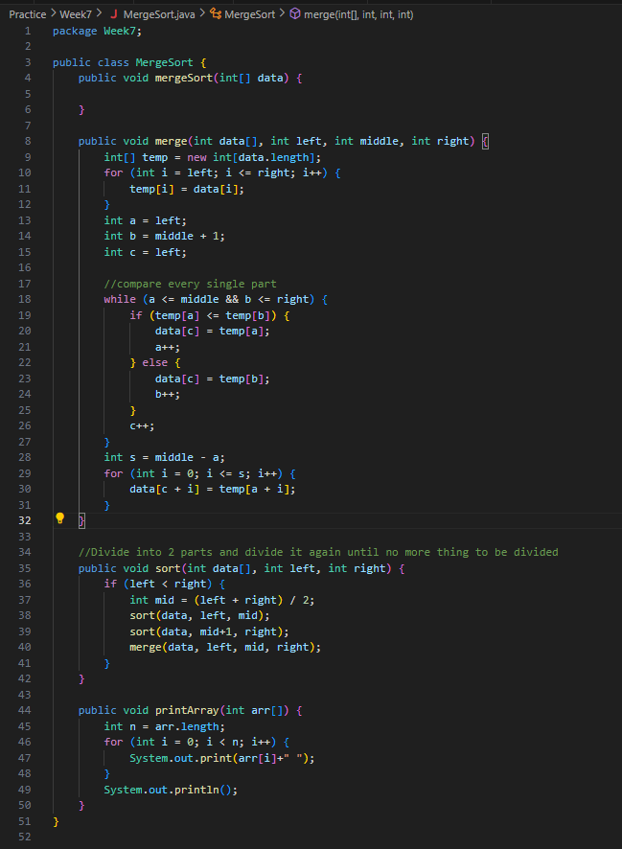

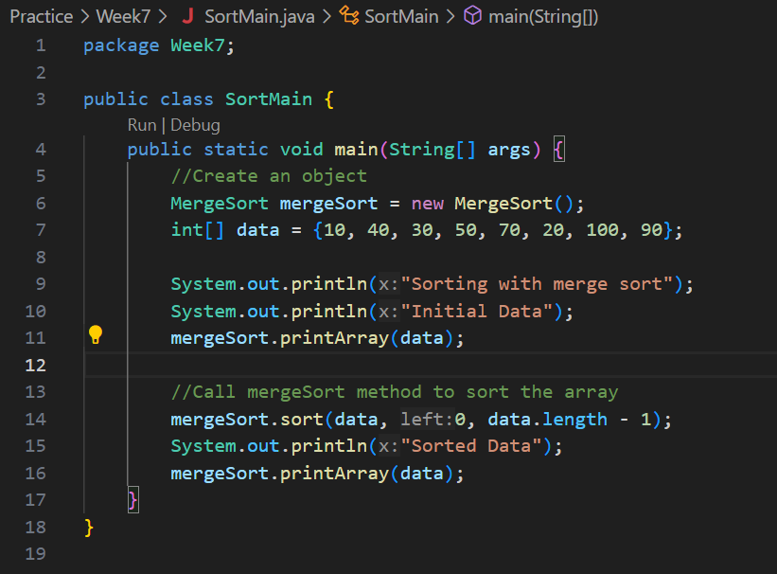

**Assignment**

1. Modify the searching program above with these requirements:
2. Before we search using binary search, we have to sort the data first. You can use whichever sorting algorithm that you are comfortable with

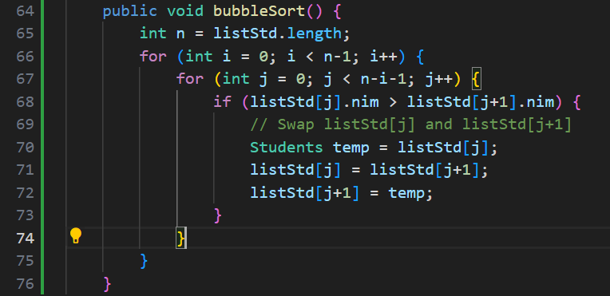 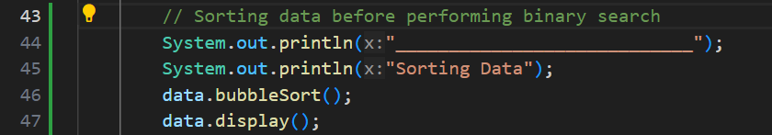

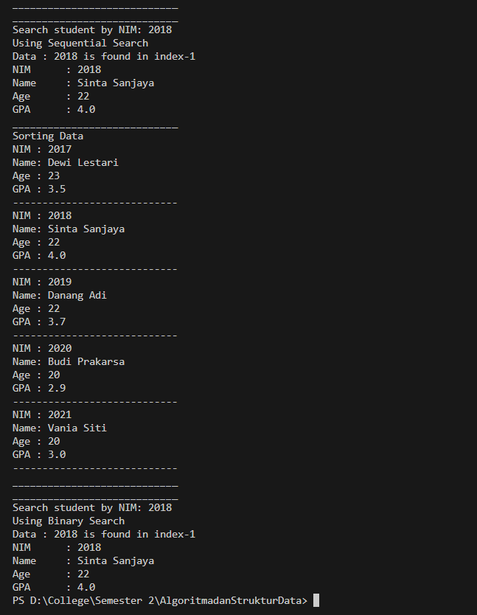

1. Modify the searching above with these requirements:

- Search by student’s name with Sequential Search algorithm

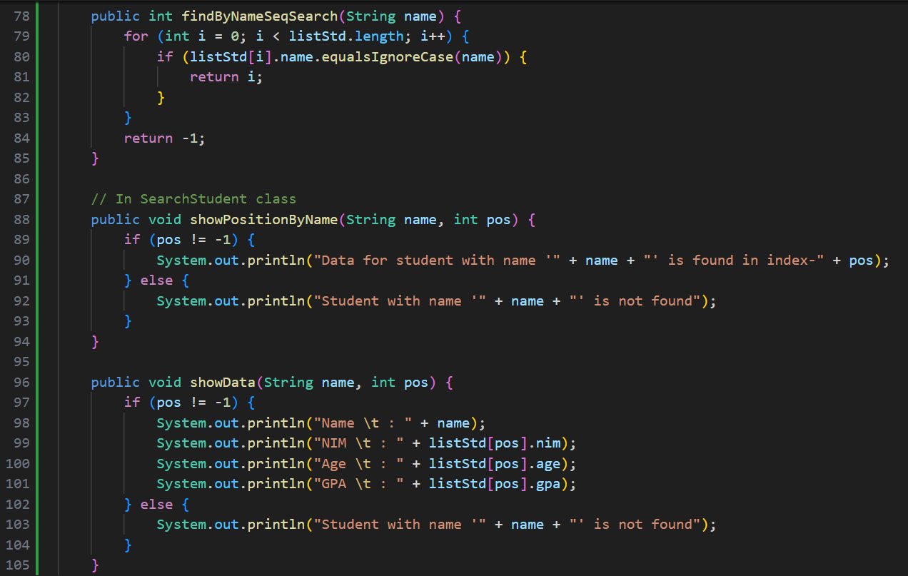

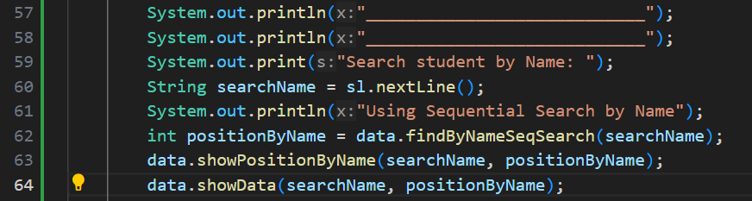 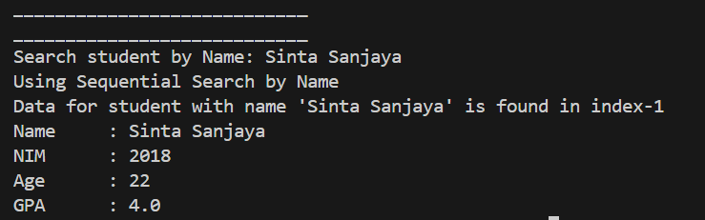

- How is the output of the program if there is any duplicate name?

If there are duplicate names in the list of students, the program will display information for the first occurrence of the name found in the list.

1. There is 2d array as follows:

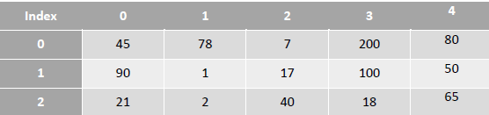

Based on data above, create a program to search data in 2d array, which the data to be searched is defined by user input (using sequential search)

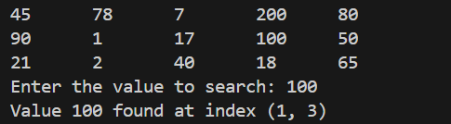

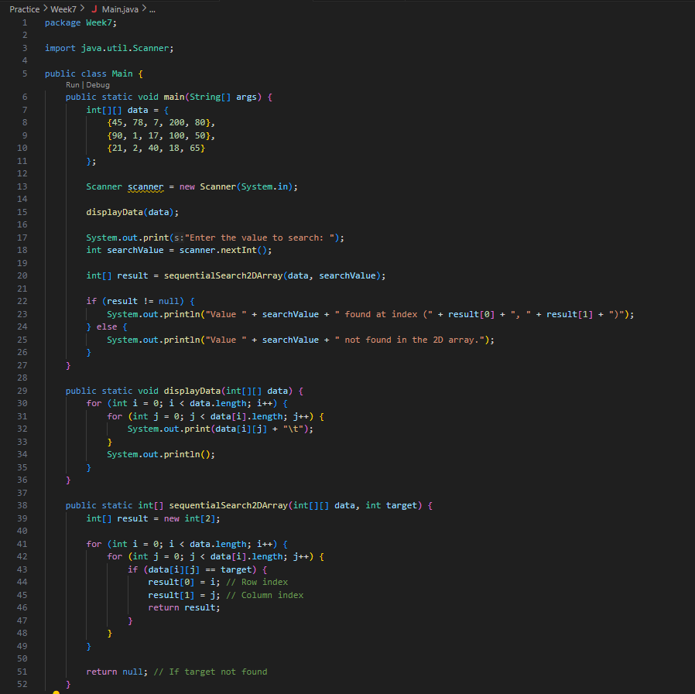

1. There is a 1D array as follows:

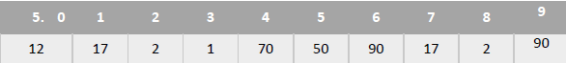

Create a program to sort the array, search & display the biggest value, and print the amount of biggest value available alongside with its position.

